React项目: Boss直聘

# 第1章: 准备

## 项目描述

* 此项目为一个**招聘的SPA**, 包括前端和后端
* 包括**用户注册/登陆, Boss/牛人列表, 实时聊天**等模块
* 前端: 使用**React全家桶+ES6+Webpack等**技术
* 后端: 使用**Node + express + mongodb + socketIO等**技术
* 采用**模块化**、**组件化**、**工程化**的模式开发

## 项目功能界面

牛人主界面 牛人消息列表 牛人个人中心

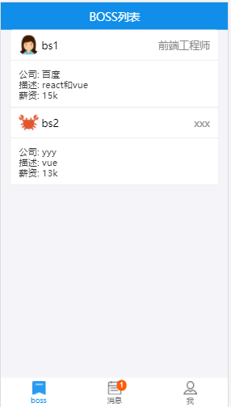 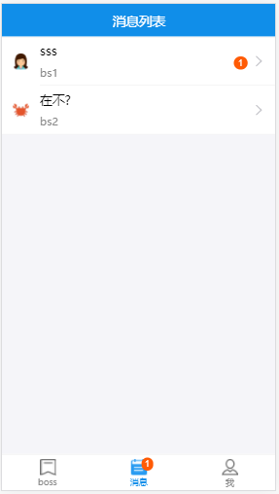 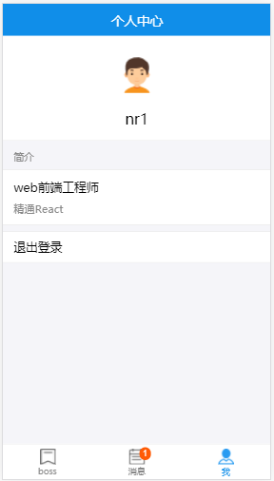

Boss主界面 Boss消息列表 Boss个人中心

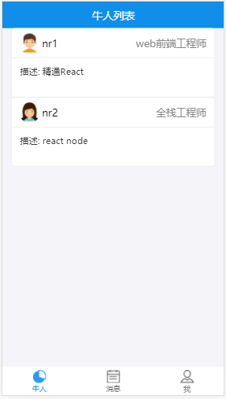 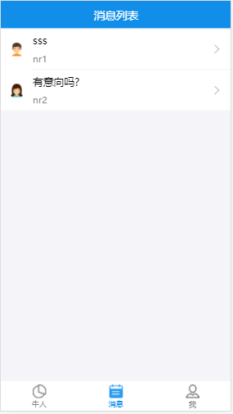 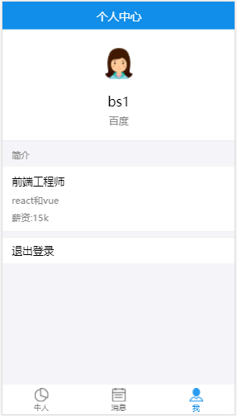

聊天界面 登陆界面 注册界面

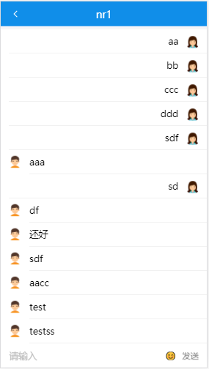 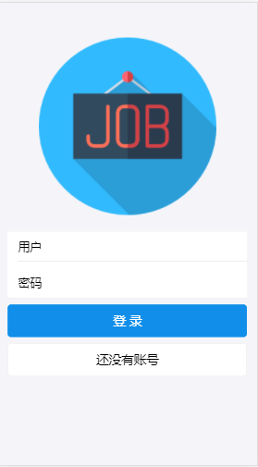 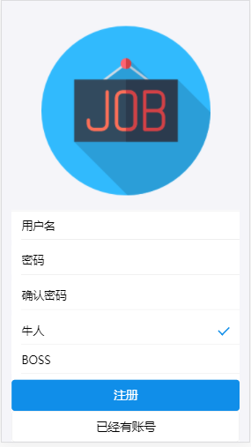

## 技术选型

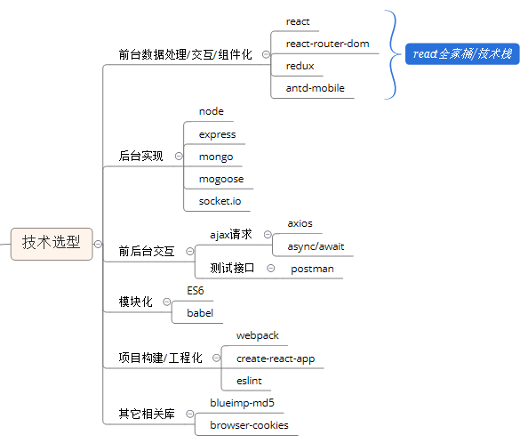

## 项目架构

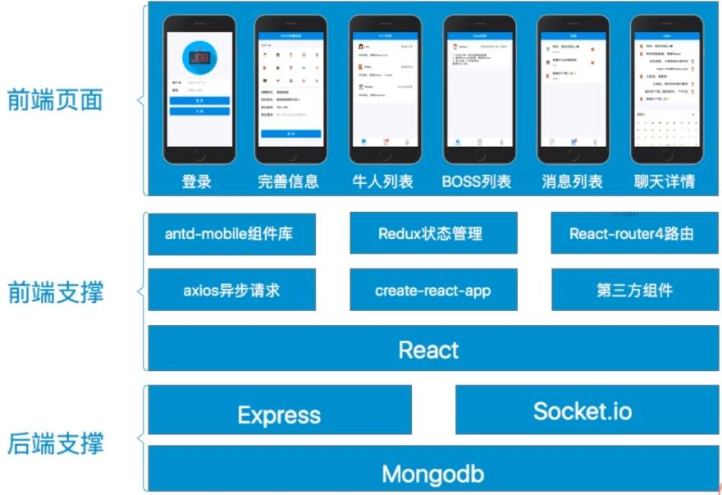

## 前端路由

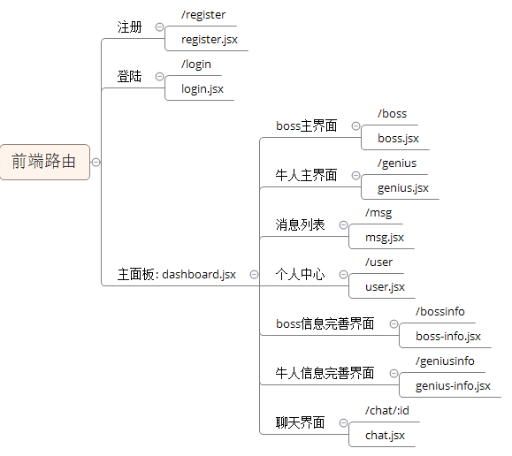

## API接口

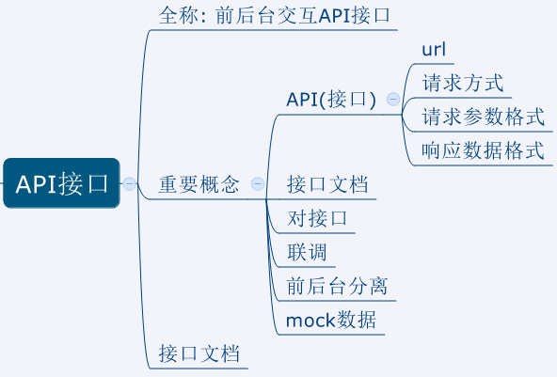

## 你能从此项目中学到什么?

* 流程及开发方法
  + 熟悉一个项目的开发流程
  + 学会**组件化、模块化、工程化**的开发模式
  + 掌握使用create-react-app**脚手架**初始化react项目
  + 学会使用**node+express+mongoose+mongodb**搭建后台
  + 学会**ES6+eslint**的开发方式
* React插件或第三方库
  + 学会使用**react-router-dom**开发单页应用
  + 学会使用**axios**与后端进行数据交互
  + 学会使用**redux+react-redux**管理应用组件状态
  + 学会使用**antd-mobile**组件库构建界面
  + 学会使用**mongoose**操作mongodb数据库
  + 学会使用**express**搭建后台路由
  + 学会使用**socket.io**实现实时通信
  + 学会使用**blueimp-md5**对密码进行MD5加密处理
  + 学会使用**browser-cookies**操作浏览器端cookie数据

## npm常用命令

|  |
| --- |
| **\*** npm init //初始化当前应用包, 生成package.json **\*** npm install //根据package.json下载所有依赖包 **\*** npm install packageName --save //下载某个运行时依赖包 **\*** npm install packageName --save-dev //下载某个开发编译期依赖包 **\*** npm install packageName -g //全局下载某个依赖包 **\*** npm install package@version //下载指定版本的某个依赖包 **\*** npm info packageName //查看某个包有远程仓库中的相关信息 **\*** npm rm packageName --save //移除已下载的运行依赖包  **\*** npm rm packageName –save-dev //移除已下载的开发依赖包 **\*** npm list //查看安装的所有的包 **\*** npm help //查看命令的详细帮助 **\*** npm install -g cnpm --registry=https://registry.npm.taobao.org //安装淘宝镜像 **\*** npm config set registry="https://registry.npm.taobao.org" //将淘宝镜像设置为npm的默认仓库  **\*** npm run xxx //执行package.json的scripts中配置的命令  **\*** npm root -g //查看全局下载目录 |

## git常用基本命令

|  |
| --- |
| **\* git config --global user.name "username" //配置用户名** **\* git config --global user.password "xx@gmail.com" //配置邮箱**  **\*** git init //初始化生成一个本地仓库  **\*** git clone url //将远程仓库克隆下载到本地  **\*** git add * //添加到暂存区  **\*** git commit –m “message” //提交到本地仓库  **\*** git remote add origin url //关联到远程仓库  **\*** git push origin master //push到远程  **\*** git pull origin master //从远程pull更新 |

# 第2章: 应用开发详解

## 开启项目开发

### 使用create-react-app(脚手架)搭建项目

* create-react-app是react官方提供的用于搭建基于react+webpack+es6项目的脚手架工具
* 在线文档: <https://github.com/facebookincubator/create-react-app>
* 操作:
  + npm install -g create-react-app : 全局下载工具
  + create-react-app chat :下载模板项目
  + cd chat
  + npm start
  + 访问: localhost:3000

### 编码测试与打包发布项目

* 编码测试
  + npm start
  + 访问: [http://localhost:3000](http://localhost:8080)
  + 编码, 自动编译打包(live-reload), 查看效果
* 打包发布
  + npm run build
  + npm install -g serve
  + serve build
  + 访问: [http://localhost:5000](http://localhost:9000)

## 功能需求分析

* 演示项目功能, 对功能模块进行分析说明

## 项目(前端)源码目录设计

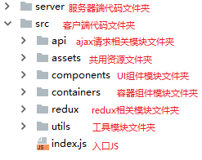

## 引入antd-mobile

### 4.1. 下载组件库包

|  |
| --- |
| **npm install antd-mobile --save** |

### 4.2. 页面处理: index.html

|  |
| --- |
| <**meta name="viewport" content="width=device-width, initial-scale=1, maximum-scale=1, minimum-scale=1, user-scalable=no"** />  <**script src="https://as.alipayobjects.com/g/component/fastclick/1.0.6/fastclick.js"**></**script**> <**script**>  **if** (**'addEventListener'** in **document**) {  **document**.addEventListener(**'DOMContentLoaded'**, **function**() {  FastClick.attach(**document**.**body**);  }, **false**);  }  **if**(!**window**.**Promise**) {  **document**.writeln(**'<script src="https://as.alipayobjects.com/g/component/es6-promise/3.2.2/es6-promise.min.js"'**+**'>'**+**'<'**+**'/'**+**'script>'**);  } </**script**> |

### 4.3. 实现组件的按需打包

* 下载工具模块

|  |
| --- |
| **npm install --save babel-plugin-import react-app-rewired** |

* 定义加载配置的js模块: config-overrides.js

|  |
| --- |
| **const** {*injectBabelPlugin*} = require(**'react-app-rewired'**); **module**.exports = **function** override(config, env) {  config = *injectBabelPlugin*([**'import'**, {**libraryName**: **'antd-mobile'**, **style**: **'css'**}], config);  **return** config; } |

* 修改配置: package.json

|  |
| --- |
| **"scripts"**: {  **"start"**: **"react-app-rewired start"**,  **"build"**: **"react-app-rewired build"**,  **"test"**: **"react-app-rewired test --env=jsdom"**,  **"eject"**: **"react-scripts eject"** } |

### 4.4. 应用中使用的组件

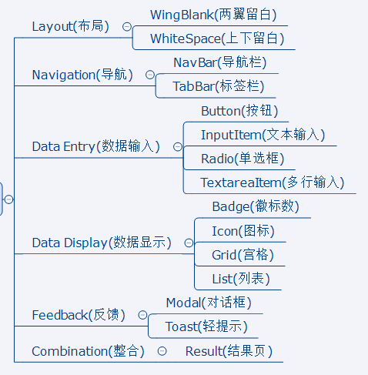

## 引入路由

### 5.1. 下载路由包: react-router-dom

|  |
| --- |
| **npm install --save react-router-dom** |

### 5.2. 路由组件: containers/register/register.jsx

|  |
| --- |
| */* 用户注册的路由组件  */* **import** React, {Component} **from 'react'  export default class** Register **extends** Component {  render() {  **return** (  <**div**>Register</**div**>  )  } } |

### 5.3. 路由组件: containers/login/login.jsx

|  |
| --- |
| */* 用户登陆的路由组件  */* **import** React, {Component} **from 'react'  export default class** Login **extends** Component {  render () {  **return** (  <**div**>login</**div**>  )  } } |

### 5.4. 路由组件: containers/dashboard/dashboard.jsx

|  |
| --- |
| */* 应用面版的路由组件  */* **import** React, {Component} **from 'react'  export default class** Dashboard **extends** Component {  render() {  **return** (  <**div**>Dashboard</**div**>  )  } } |

### 5.5. 映射路由: index.js

|  |
| --- |
| */* 入口JS  */*  **import** React **from 'react' import** ReactDOM **from 'react-dom' import** {**BrowserRouter**, **Switch**, **Route**} **from 'react-router-dom'  import** Login **from './containers/login/login' import** Register **from './containers/register/register' import** Dashboard **from './containers/dashboard/dashboard'** ReactDOM.render((  <**BrowserRouter**>  <**Switch**>  <**Route path='/login' component=**{Login}/>  <**Route path='/register' component=**{Register}/>  <**Route component=**{Dashboard}/>  </**Switch**>  </**BrowserRouter**> ), **document**.getElementById(**'root'**)) |

## 引入redux

### 6.1. 下载相关依赖包

|  |
| --- |
| **npm install --save redux react-redux redux-thunk**  **npm install --save-dev redux-devtools-extension** |

### 6.2. reducers: redux/reducers.js

|  |
| --- |
| */* 包含多个用于生成新的state的reducer函数的模块  */*  **import** {*combineReducers*} **from 'redux'  function** *xxx*(state = 0, action) {   **return** state }  **function** *yyy*(state = 0, action) {   **return** state }  **export default** *combineReducers*({  *xxx*,  *yyy* }) |

### 6.3. store: redux/store.js

|  |
| --- |
| */* redux最核心的store对象模块  */*  **import** {createStore, *applyMiddleware*} **from 'redux' import** thunk **from 'redux-thunk' import** {**composeWithDevTools**} **from 'redux-devtools-extension' import** reducers **from './reducers'  export default** createStore(reducers, **composeWithDevTools**(*applyMiddleware*(thunk))) |

### 6.4. 入口JS: index.js

|  |
| --- |
| /* 入口JS  */  **import** React **from 'react' import** ReactDOM **from 'react-dom' import** {Provider} **from 'react-redux' import** {**BrowserRouter**, **Switch**, **Route**} **from 'react-router-dom'  import** store **from './redux/store' import** Login **from './containers/login/login' import** Register **from './containers/register/register' import** Dashboard **from './containers/dashboard/dashboard'** ReactDOM.render((  <**Provider store=**{store}>  <**BrowserRouter**>  <**Switch**>  <**Route path='/login' component=**{Login}/>  <**Route path='/register' component=**{Register}/>  <**Route component=**{Dashboard}/>  </**Switch**>  </**BrowserRouter**>  </**Provider**> ), **document**.getElementById(**'root'**)) |

## 注册/登陆界面

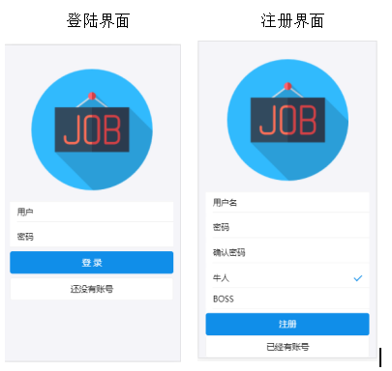

### 7.1. Logo组件

1. components/logo/logo.jsx

|  |
| --- |
| */* 显示logo图片的UI组件  */*  **import** React **from 'react' import** logoImg **from './job.png' import './logo.css'  class** Logo **extends** React.Component {   render() {  **return** (  <**div className="logo-container"**>  <**img src=**{logoImg} **alt="logo"**/>  </**div**>  )  } }  **export default** Logo |

1. components/logo/logo.css

|  |
| --- |
| .**logo-container** {  **margin-top**: 10**px**;  **text-align**: **center**;  **margin-bottom**: 10**px**; } |

1. components/logo/job.png



### 7.2. 登陆组件: containers/login/login.jsx

|  |
| --- |
| */* 用户登陆的路由组件  */* **import** React, {Component} **from 'react' import** {WingBlank, List, InputItem, WhiteSpace, Button} **from 'antd-mobile'  import** *Logo* **from '../../components/logo/logo'  export default class** Login **extends** Component {  **state** = {  **name**: **''**,  **pwd**: **''**,  }   *// 处理输入框/单选框变化, 收集数据到state  handleChange* = (name, value) => {  **this**.setState({[name]: value})  }   *// 跳转到注册路由  toRegister* = () => {  **this**.**props**.**history**.**replace**(**'/register'**)  }   *// 注册  login* = () => {  **console**.log(***JSON***.stringify(**this**.**state**))  }   render() {  **return** (  <**div**>  <**Logo**/>  <**WingBlank**>  <**List**>  <**InputItem  placeholder='输入用户名'  onChange=**{val => **this**.*handleChange*(**'name'**, val)}  >  用户名:  </**InputItem**>  <**WhiteSpace**/>  <**InputItem  type='password'  placeholder='输入密码'  onChange=**{val => **this**.*handleChange*(**'pwd'**, val)}  >  密 码:  </**InputItem**>  <**WhiteSpace**/>   <**Button type='primary' onClick=**{**this**.*login*}>登 陆</**Button**>  <**WhiteSpace**/>  <**Button onClick=**{**this**.*toRegister*}>还没有账号</**Button**>  </**List**>  </**WingBlank**>  </**div**>  )  } } |
|  |

### 7.3. 注册组件: containers/register/register.jsx

|  |
| --- |
| */* 用户注册的路由组件  */* **import** React, {Component} **from 'react' import** {WingBlank, List, InputItem, WhiteSpace, Radio, Button} **from 'antd-mobile'  import** *Logo* **from '../../components/logo/logo'  const** RadioItem = Radio.*RadioItem* **export default class** Register **extends** Component {  **state** = {  **name**: **''**,  **pwd**: **''**,  **pwd2**: **''**,  **type**: **'boss'** }   *// 处理输入框/单选框变化, 收集数据到state  handleChange* = (name, value) => {  **this**.setState({[name]: value})  }   *// 跳转到login路由  toLogin* = () => {  **this**.**props**.**history**.**replace**(**'/login'**)  }   *// 注册  register* = () => {  **console**.log(***JSON***.stringify(**this**.**state**))  }   render() {  **const** {**type**} = **this**.**state  return** (  <**div**>  <**Logo**/>  <**WingBlank**>  <**List**>  <**InputItem  placeholder='输入用户名'  onChange=**{val => **this**.*handleChange*(**'name'**, val)}  >  用户名:  </**InputItem**>  <**WhiteSpace**/>  <**InputItem  type='password'  placeholder='输入密码'  onChange=**{val => **this**.*handleChange*(**'pwd'**, val)}  >  密 码:  </**InputItem**>  <**WhiteSpace**/>  <**InputItem  type='password'  placeholder='输入确认密码'  onChange=**{val => **this**.*handleChange*(**'pwd2'**, val)}  >  确认密码:  </**InputItem**>  <**WhiteSpace**/>  <**RadioItem  checked=**{**type** === **'boss'**}  **onChange=**{() => **this**.*handleChange*(**'type'**, **'boss'**)}  >  BOSS  </**RadioItem**>  <**RadioItem  checked=**{**type** === **'genius'**}  **onChange=**{() => **this**.*handleChange*(**'type'**, **'genius'**)}  >  牛人  </**RadioItem**>  <**WhiteSpace**/>  <**Button type='primary' onClick=**{**this**.*register*}>注 册</**Button**>  <**WhiteSpace**/>  <**Button onClick=**{**this**.*toLogin*}>已经有账号</**Button**>  </**List**>  </**WingBlank**>  </**div**>  )  } } |

## 搭建后台(基本)

### 8.1. 下载相关依赖包

|  |
| --- |
| **npm install --save-dev express**  **npm install -g nodemon** |

### 8.2. 实现最基本的服务器端

1. server/server.js

|  |
| --- |
| */* 后台启动服务器的入口模块 1. 引入express 2. 生成应用对象(执行express函数) 3. 注册根路由(使用app的use()) 4. 启动服务器(使用app监听指定端口)  */  // 1. 引入express* **const** express = require(**'express'**)  *// 2. 生成应用对象(执行express函数)* **const** app = express()  *// 3. 注册根路由(使用app的use())* app.use(**'/'**, **function** (req, res) {  res.send(**'hello server222!'**) })  *// 4. 启动服务器(使用app监听指定端口)* app.listen(**'8888'**, () => {  **console**.log(**'start server at port 8888'**) }) |

1. 配置启动服务器命令: package.json

|  |
| --- |
| **"server"**: **"nodemon server/server.js"** |

1. 运行访问

|  |
| --- |
| **npm run server**  **http://localhost:8888** |

### 8.2. 使用postman测试接口

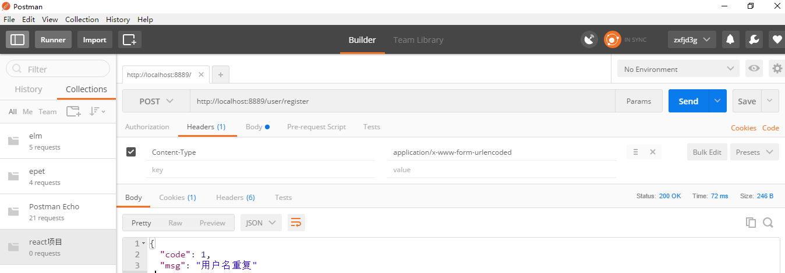

<http://blog.csdn.net/ye1992/article/details/49998511>: 不同的post提交方式

## 使用mongoose操作数据库

### 9.1. 下载依赖包

|  |
| --- |
| **npm install --save-dev mongoose** |

### 9.2. server/db_test.js

|  |
| --- |
| */* 测试使用mongoose操作mongodb数据库的模块 1. 连接数据库  1.1. 引入mongoose  1.2. 连接指定数据库(URL只有数据库是变化的)  1.3. 获取连接对象  1.4. 绑定连接完成的监听(用来提示连接成功) 2. 得到对应特定集合的Model  2.1. 字义Schema(描述文档结构)  2.2. 定义Model(与集合对应, 可以操作集合) 3. 通过Model或其实例对集合数据进行CRUD操作  3.1. 通过Model实例的save()添加数据  3.2. 通过Model的find()/findOne()查询多个或一个数据  3.3. 通过Model的findByIdAndUpdate()更新某个数据  3.4. 通过Model的remove()删除匹配的数据  */  /*1. 连接数据库*/ // 1.1. 引入mongoose* **const** mongoose = require(**'mongoose'**) *// 1.2. 连接指定数据库(URL只有数据库是变化的)* mongoose.connect(**'mongodb://localhost:27017/bossz_test'**) *// 1.3. 获取连接对象* **const** conn = mongoose.**connection** *// 1.4. 绑定连接完成的监听(用来提示连接成功)* conn.**on**(**'connected'**,**function**(){  **console**.log(**'连接数据库成功！'**) })  */*2. 得到对应特定集合的Model*/ // 2.1. 字义Schema(描述文档结构)* **const** userSchema = mongoose.Schema({  *// 用户名* **'name'**: {**type**: String, **'require'**: **true**},  *// 密码* **'pwd'**: {**type**: String, **'require'**: **true**},  *// 类型* **'type'**: {**'type'**: String, **'require'**: **true**},  *// 头像* **'avatar'**: {**'type'**: String},  *// 个人简介或者职位简介* **'desc'**: {**'type'**: String},  *// 职位名* **'title'**: {**'type'**: String},  *// 如果你是boss 还有两个字段  // 公司名称* **'company'**: {**'type'**: String},  *// 工资* **'money'**: {**'type'**: String} }) *// 2.2. 定义Model(与集合对应, 可以操作集合) //const UserModel = mongoose.model('user', userSchema) // 集合的名称为users* mongoose.model(**'user'**, userSchema) **const** UserModel = mongoose.model(**'user'**)  */*3. 通过Model或其实例对集合数据进行CRUD操作*/  // 3.1. 通过Model实例的save()添加数据* **function** *testSave*() {  **const** userModel = **new** UserModel({  **name**: **'Jack'**,  **pwd**: **'123'**,  **type**: **'genius'**,  **avatar**: **'boy'** })  userModel.save(userModel, **function** (err, user) {  **console**.log(**'save()'**, err, user)  }) }  // *testSave*()  *// 3.2. 通过Model的find()/findOne()查询多个或一个数据* **function** *testFind*() {  UserModel.find(**function** (err, users) { *// 如果没有匹配的, 返回[]* **console**.log(**'find()'**, err, users)  })   UserModel.findOne({**_id**: **'5a69d23dcbe9821448e5f799'**}, **function** (err, user) { *// 如果没有匹配的, 返回null* **console**.log(**'findOne()'**, err, user)  }) }  *// testFind()  // 3.3. 通过Model的findByIdAndUpdate()更新某个数据* **function** *testUpdate*() {  UserModel.findByIdAndUpdate({**_id**: **'5a69d23dcbe9821448e5f799'**}, {**name**: **'BB'**}, **function** (err, user) {  **console**.log(**'findByIdAndUpdate()'**, err, user)  }) }  *// testUpdate()  // 3.4. 通过Model的remove()删除匹配的数据* **function** *testRemove*() {  UserModel.remove({**_id**: **'5a69d23dcbe9821448e5f799'**}, **function** (err, result) {  **console**.log(**'remove()'**, err, result) *// { ok: 1, n: 1 }* }) } *// testRemove()* |

### 9.3. 安装webstorm的mongo插件: Mongo Plugin

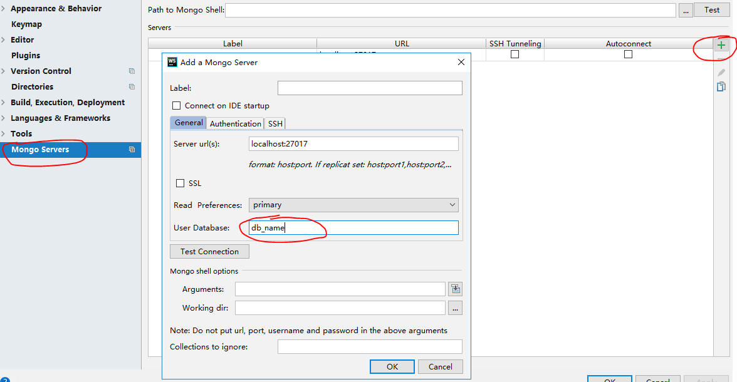

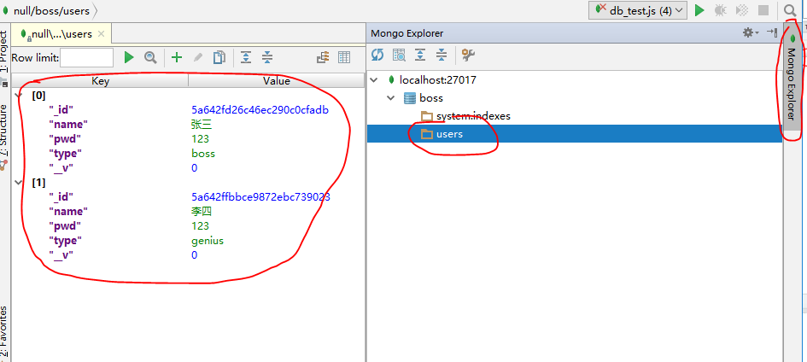

## 注册/登陆后台处理

### 10.1. 下载相关依赖包

|  |
| --- |
| **npm install --save-dev body-parser cookie-parser**  **npm install --save-dev blueimp-md5** |

### 10.2. 数据库操作模块: server/models.js

|  |
| --- |
| */* 包含n个能操作mongodb数据库集合的model的模块 1. 连接数据库  1.1. 引入mongoose  1.2. 连接指定数据库(URL只有数据库是变化的)  1.3. 获取连接对象  1.4. 绑定连接完成的监听(用来提示连接成功) 2. 定义对应特定集合的Model  2.1. 字义Schema(描述文档结构)  2.2. 定义Model(与集合对应, 可以操作集合) 3. 向外暴露获取Model的方法  */ // 1. 连接数据库* **const** mongoose = require(**'mongoose'**) mongoose.connect(**'mongodb://localhost:27017/bossz'**) **const** conn = mongoose.**connection** conn.**on**(**'connected'**, **function** () {  **console**.log(**'数据库连接成功!'**) })  *// 2. 得到对应特定集合的Model: UserModel* **const** userSchema = mongoose.Schema({  *// 用户名* **'name'**: {**type**: String, **required**: **true**},  *// 密码* **'pwd'**: {**type**: String, **required**: **true**},  *// 类型* **'type'**: {**'type'**: String, **required**: **true**},  *// 头像* **'avatar'**: {**'type'**: String},  *// 个人简介或者职位简介* **'desc'**: {**'type'**: String},  *// 职位名* **'title'**: {**'type'**: String},  *// 如果你是boss 还有两个字段  // 公司名称* **'company'**: {**'type'**: String},  *// 工资* **'money'**: {**'type'**: String} }) **UserModel** = mongoose.model(**'user'**, userSchema)  *// 3. 向外暴露* **module**.**exports** = {  getModel(name) {  **return** mongoose.model(name)  } } |

### 10.3. 应用路由器模块: server/appRouter.js

|  |
| --- |
| */* 后台应用的路由器模块 1. 引入express 2. 得到路由器 3. 注册n个路由 4. 向外暴露路由器 5. 通过 app使用上路由器  */ // 1. 引入express* **const** express = require(**'express'**) **const** md5 = require(**'blueimp-md5'**) **const models** = require(**'./models'**) **const** UserModel = **models**.getModel(**'user'**) *// 2. 得到路由器* **const** router = express.Router() **const** _filter = {**'pwd'**: 0, **'__v'**: 0} *// 查询时过滤掉  // 3. 注册n个路由  // 用户注册的路由 /* 路由回调函数的3步 1. 获取请求参数 2. 处理(操作数据库数据) 3. 返回响应  */* router.post(**'/register'**, **function** (req, res) {  *// 1. 获取请求参数* **const** {name, pwd, type} = req.**body** *// 包含所有请求参数的对象   // 2. 处理(操作数据库数据)  // 2.1. 根据name查询是否已经存在,* UserModel.findOne({name}, **function** (err, user) {  *// 3.1. 如果已经存在, 返回一个错误的提示* **if**(user) {  **return** res.send({**code**: 1, **msg**: **'用户名已存在!'**}) *// code: 数据的标识 1: 错误 0: 正确* }  *// 2.2. 如果不存在, 保存到数据库,* **const** userModel = **new** UserModel({name, **pwd**: md5(pwd), type})  userModel.save(**function** (err, user) {  *// 向浏览器端返回cookie(key=value)* res.cookie(**'userid'**, user.**_id**)  *// 3.2. 返回数据(新的user)* res.send({**code**: 0, **data**: {**_id**: user.**_id**, name, pwd, type}})  })  }) })  *// 用户登陆的路由* router.post(**'/login'**, **function** (req, res) {  *// 1. 获取请求参数* **const** {name, pwd} = req.**body** *// 2. 根据name和pwd查询对应的user* UserModel.findOne({name, **pwd**: md5(pwd)}, _filter, **function** (err, user) {  *// 3.1. 存在, 返回user数据* **if**(user) {  *// 向浏览器端返回cookie(key=value)* res.cookie(**'userid'**, user.**_id**)  res.json({**code**: 0, **data**: user})  } **else** {  *// 3.2. 不存在, 返回错误信息* res.json({**code**: 1, **msg**: **'用户名或密码错误!'**})  }  })  })  *// 4. 向外暴露路由器* **module**.**exports** = router |

### 10.4. 服务器模块: server/server.js

|  |
| --- |
| */* 使用express启动服务器 1. 引入express 2. 生成应用对象(执行express函数) 3. 注册根路由(使用app的use()) 4. 启动服务器(使用app监听指定端口)  */ // 1. 引入express* **const** express = require(**'express'**) **const** bodyParser = require(**'body-parser'**) *// 解析请求体* **const** cookieParser = require(**'cookie-parser'**) *// 引入应用的路由器* **const** appRouter = require(**'./app_router'**)  *// 2. 生成应用对象(执行express函数)* **const** app = express()  *// 3. 注册根路由(使用app的use()) /*app.use('/', function (req, res) {  res.send('hello server!2222') })*/* app.use(cookieParser()) *// 解析cookie数据* app.use(bodyParser.**json**()) *// 解析请求体(ajax请求: json数据格式)* app.use(bodyParser.**urlencoded**({ **extended**: **false** })) *// 解析请求体(表单数据) // 注册路由器* app.use(**'/api'**, appRouter) *// 登陆: /api/login  // 4. 启动服务器(使用app监听指定端口)* app.listen(4000, **function** () {  **console**.log(**'服务器启动成功 port: 4000'**) }) |

## 注册/登陆前台处理

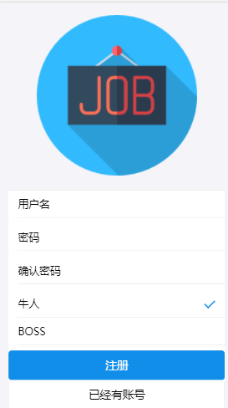 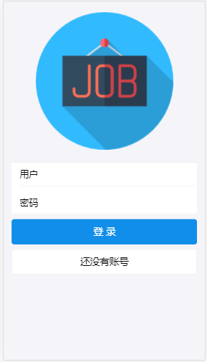

### 11.1. 下载相关依赖包

|  |
| --- |
| **npm install --save axios** |

### 11.2. 封装ajax请求代码

1. api/ajax.js

|  |
| --- |
| */* 使用axios封装的ajax请求方法  */*  **import** axios **from 'axios' import** {Toast} **from 'antd-mobile'  export default function** ajax(url = **''**, data = {}, type = **'GET'**) {  **return new** Promise(**function** (resolve, reject) {   **let** promise   **if** (type === **'GET'**) {  *// 准备url query参数数据* **let** dataStr = **''** *//数据拼接字符串* Object.keys(data).forEach(key => {  dataStr += key + **'='** + data[key] + **'&'** })  **if** (dataStr !== **''**) {  dataStr = dataStr.substr(0, dataStr.lastIndexOf(**'&'**))  url = url + **'?'** + dataStr  }  *// 发送get请求* promise = axios.get(url)  } **else** {  *// 发送post请求* promise = axios.post(url, data)  }   promise.then(response => {  resolve(response.**data**)  })  .catch(error => {  reject(error)  })  }) } **let** toastShowing = **false** *// 拦截请求* axios.interceptors.request.use(**function** (config) {  **console**.log(**'拦截请求'**)  **if** (toastShowing) {  **return** config  }  Toast.*loading*(**'加载中'**, 0)  toastShowing = **true   return** config })  *// 拦截响应* axios.interceptors.response.use(**function** (config) {  **console**.log(**'拦截响应'**)  **if**(toastShowing) {  Toast.*hide*()  toastShowing = **false** }  **return** config }) |

1. api/index.js

|  |
| --- |
| **import** *ajax* **from './ajax'** *// 请求注册* **export const** *reqRegister* = (user) => *ajax*(**'/api/register'**, user, **'POST'**) *// 请求登陆* **export const** *reqLogin* = (user) => *ajax*(**'/api/login'**, user, **'POST'**) |

1. 配置ajax请求的代理: package.json

|  |
| --- |
| **"proxy"**: **"http://localhost:8888"** |

### 11.3. 使用redux管理用户信息

1. redux/action-types.js

|  |
| --- |
| */* 包含所有action的type常量名称的模块 */*  *// 验证成功* **export const** AUTH_SUCCESS = **'AUTH_SUCCESS'** *// 请求出错* **export const** ERROR_MSG = **'ERROR_MSG'** |

1. redux/actions.js

|  |
| --- |
| */* 包含所有action creator函数的模块  */* **import** {  AUTH_SUCCESS,  ERROR_MSG } **from './action-types' import** {  *reqRegister*,  *reqLogin* } **from '../api'** *// 同步错误消息* **const** *errorMsg* = (msg) => ({**type**:ERROR_MSG, **data**: msg}) *// 同步成功响应* **const** *authSuccess* = (user) => ({**type**: AUTH_SUCCESS, **data**: user})  */* 异步注册  */* **export function** *register*({name, pwd, pwd2, type}) {  **if** (!name || !pwd || !type) {  **return** *errorMsg*(**'用户名密码必须输入'**)  }  **if** (pwd !== pwd2) {  **return** *errorMsg*(**'密码和确认密码不同'**)  }  **return async** dispatch => {  **const** result = **await** *reqRegister*({name, pwd, type})  **if** (result.**code** === 0) {  dispatch(*authSuccess*(result.**data**))  } **else** {  dispatch(*errorMsg*(result.**msg**))  }  } }  */* 异步登陆  */* **export const** *login* = ({name, pwd}) => {  **if** (!name || !pwd) {  **return** *errorMsg*(**'用户密码必须输入'**)  }  **return async** dispatch => {  **const** result = **await** *reqLogin*({name, pwd})  **if** (result.**code** === 0) {  dispatch(*authSuccess*(result.**data**))  } **else** {  dispatch(*errorMsg*(result.**msg**))  }  } } |

1. redux/reducers.js

|  |
| --- |
| */* 包含n个根据老的state和action返回新的state的函数的模块  */* **import** {*combineReducers*} **from 'redux'  import** {  AUTH_SUCCESS,  ERROR_MSG } **from './action-types'  const** initUser = {  **name**: **''**, *// 用户名* **type**: **''**, *// 类型* **msg**: **''**, *// 错误提示信息* **redirectTo**: **''** *// 需要自动跳转的路由path* } **function** *user*(state = initUser, action) {  **switch** (action.**type**) {  **case** AUTH_SUCCESS: *// 认证成功* **return** {...action.**data**, **redirectTo**: **'/'**}  **case** ERROR_MSG: *// 错误信息提示* **return** {...state, **msg**: action.**data**}  **default**:  **return** state  } }  **export default** *combineReducers*({  *user* }) |

### 11.4. 注册组件: register.jsx

|  |
| --- |
| */* 用户注册的路由组件  */* **import** React, {Component} **from 'react' import** {List, WingBlank, InputItem, Radio, WhiteSpace, Button} **from 'antd-mobile' import** {connect} **from 'react-redux' import** {**Redirect**} **from 'react-router-dom'  import** Logo **from '../../components/logo/logo' import** {*regisger*} **from '../../redux/actions'  const** RadioItem = Radio.*RadioItem* **class** Register **extends** Component {   **state** = {  **name**: **''**,  **pwd**: **''**,  **pwd2**: **''**,  **type**: **'genius'** }   *toLogin* = () => **this**.**props**.**history**.replace(**'/login'**)   *handleChange* = (key, val) => **this**.setState({[key]: val})   *handleRegister* = () => **this**.**props**.**regisger**(**this**.**state**)   render() {   **const** {redirectTo, msg} = **this**.**props  if** (redirectTo) {  **return** <**Redirect to=**{redirectTo}/>  }   **return** (  <**div**>  <**Logo**></**Logo**>  <**WingBlank**>  {msg ? <**p className='error-msg'**>{msg}</**p**> : **null**}  <**List**>  <**InputItem  onChange=**{val => **this**.*handleChange*(**'name'**, val)}  >用户名</**InputItem**>  <**WhiteSpace**/>  <**InputItem  type='password'  onChange=**{val => **this**.*handleChange*(**'pwd'**, val)}  >密码</**InputItem**>  <**WhiteSpace**/>  <**InputItem  type='password'  onChange=**{val => **this**.*handleChange*(**'pwd2'**, val)}  >确认密码</**InputItem**>  <**WhiteSpace**/>  <**RadioItem  checked=**{**this**.**state**.**type** === **'genius'**}  **onChange=**{() => **this**.*handleChange*(**'type'**, **'genius'**)}  >  牛人  </**RadioItem**>  <**RadioItem  checked=**{**this**.**state**.**type** === **'boss'**}  **onChange=**{() => **this**.*handleChange*(**'type'**, **'boss'**)}  >  BOSS  </**RadioItem**>  <**WhiteSpace**/>  <**Button type='primary' onClick=**{**this**.*handleRegister*}>注册 </**Button**>  <**Button onClick=**{**this**.*toLogin*}>已经有账号</**Button**>  </**List**>  </**WingBlank**>   </**div**>  )  } }  **export default** connect(  state => state.**user**,  {*regisger*} )(Register) |

### 11.5. 登陆组件: login.jsx

|  |
| --- |
| */* 用户登陆的路由组件  */* **import** React, {Component} **from 'react' import** {List, InputItem, WingBlank, WhiteSpace, Button} **from 'antd-mobile' import** {connect} **from 'react-redux' import** {**Redirect**} **from 'react-router-dom'  import** Logo **from '../../components/logo/logo' import** {*login*} **from '../../redux/actions'  class** Login **extends** Component {   **state** = {  **name**: **''**,  **pwd**: **''** }   *toRegister* = () => **this**.**props**.**history**.push(**'/register'**)   *handleChange* = (key, val) => **this**.setState({[key]: val})   *handleLogin* = () => **this**.**props**.**login**(**this**.**state**)   render() {   **const** {redirectTo, msg} = **this**.**props  if** (redirectTo) {  **return** <**Redirect to=**{redirectTo}/>  }   **return** (  <**div**>  <**Logo**></**Logo**>  <**WingBlank**>  {msg ? <**p className='error-msg'**>{msg}</**p**> : **null**}  <**List**>  <**InputItem  onChange=**{v => **this**.*handleChange*(**'name'**, v)}  >用户</**InputItem**>  <**WhiteSpace**/>  <**InputItem  onChange=**{v => **this**.*handleChange*(**'pwd'**, v)}  **type='password'** >密码</**InputItem**>  </**List**>  <**WhiteSpace**/>  <**Button type='primary' onClick=**{**this**.*handleLogin*}>登录</**Button**>  <**WhiteSpace**/>  <**Button onClick=**{**this**.*toRegister*}>还没有账号</**Button**>  </**WingBlank**>  </**div**>  )  } }  **export default** connect(  state => state.**user**,  {*login*} )(Login) |
|  |

### 11.6. 样式: assets/css/index.css

|  |
| --- |
| .**error-msg** {  **color**: red;  **text-align**: **center**;  **font-size**: 18**px**; }  需要在index.js中引入 |

## 实现user信息完善功能

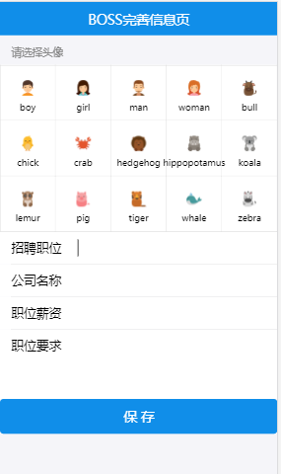 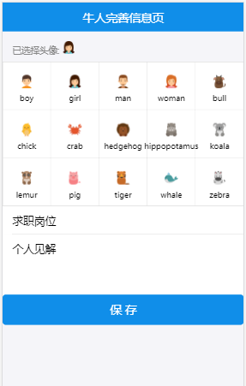

### 12.1. 注册/登陆成功的路由跳转

1. 工具模块: utils/index.js

|  |
| --- |
| */* 包含一些工具函数的模块  */  /**  * 得到重定向的路径  */* **export function** *getRedirectPath*({type, avatar}) {  *// 根据用户信息 返回跳转地址  // user.type /boss /genius  // user.avatar /bossinfo /geniusinfo* **let** url = (type === **'boss'**) ? **'/boss'** : **'/genius'  if** (!avatar) {  url += **'info'** }  **return** url } |

1. reducers中使用工具: redux/reducers.js

|  |
| --- |
| **import** {*getRedirectPath*} **from '../utils'**  **case** AUTH_SUCCESS: *// 认证成功* **const** user = action.**data  const** {type, avatar} = user  **return** {...user, **redirectTo**: *getRedirectPath*({type, avatar})} |

### 12.2. 后台路由: server/appRouter.js

|  |
| --- |
| */* 更新用户  */* router.post(**'/update'**, **function** (req, res) {  **const** userid = req.**cookies**.**userid  if** (!userid) {  **return** res.json({**code**: 1, **msg**: **'用户未登陆或注册'**})  }   UserModel.findByIdAndUpdate(userid, req.**body**, **function** (err, user) {  **console**.log(**'update()'**, user)  **const** {name, type} = user  user = Object.assign({}, req.**body**, {name, type})  **return** res.json({**code**: 0, **data**: user})  }) }) |

### 12.3. 更新的ajax请求: api/index.js

|  |
| --- |
| *// 更新用户信息* **export const** *reqUpdateUser* = (user) => *ajax*(**'/api/update'**, user, **'POST'**) |

### 12.4. redux更新状态: redux/actions.js

|  |
| --- |
| **import** {  *reqUpdateUser* } **from '../api'**  *// 异步更新用户* **export const** *updateUser* = user => {  **return async** dispatch => {  **const** result = **await** *reqUpdateUser*(user)  **if** (result.**code** === 0) {  dispatch(*authSuccess*(result.**data**))  } **else** {  dispatch(*errorMsg*(result.**msg**))  }  } } |

### 12.5. 用户头像选择组件:

1. 添加多个头像图片文件: assets/imgs



1. 组件: components/avatar-selector/avatar-selector.jsx

|  |
| --- |
| */* 选择头像的UI组件  */*  **import** React **from 'react' import** {Grid, List} **from 'antd-mobile' import** PropTypes **from 'prop-types'  class** AvatarSelector **extends** React.Component {   **static** *propTypes* = {  **selectAvatar**: PropTypes.*func*.isRequired  }   **state** = {  **icon**: **null**,  **text**: **''** }   componentWillMount() {  **this**.**avatarList** = **'boy,girl,man,woman,bull,chick,crab,hedgehog,hippopotamus,koala,lemur,pig,tiger,whale,zebra'** .split(**','**)  .map(text => ({  **icon**: require(**`../../assets/imgs/**${text}**.png`**),  text  }))  }   render() {   **const** gridHeader = **this**.**state**.**icon** ? (  <**div**>  <**span**>已选择头像: </**span**>  <**img style=**{{**width**: 20}} **src=**{**this**.**state**.**icon**} **alt="avatar"**/>  </**div**>  )  : **'请选择头像'  return** (  <**div**>  <**List  renderHeader=**{() => gridHeader}  >  <**Grid  data=**{**this**.**avatarList**}  **columnNum=**{5}  **onClick=**{item => {  **this**.setState(item)  **this**.**props**.**selectAvatar**(item.**text**)  }}  />  </**List**>  </**div**>  )  } }  **export default** AvatarSelector |

### 12.6. boss信息完善组件: containers/boss-info/boss-info.jsx

|  |
| --- |
| */* 完善boss信息的路由组件  */*  **import** React **from 'react' import** {NavBar, InputItem, TextareaItem, Button} **from 'antd-mobile' import** {connect} **from 'react-redux' import** {**Redirect**} **from 'react-router-dom'  import** AvatarSelector **from '../../components/avatar-selector/avatar-selector' import** {*updateUser*} **from '../../redux/actions'  class** BossInfo **extends** React.Component {   **state** = {  **title**: **''**,  **desc**: **''**,  **company**: **''**,  **money**: **''** }   *onChange* = (key, val) => {  **this**.setState({[key]: val})  }   render() {   **const** path = **this**.**props**.**location**.**pathname  const** redirectTo = **this**.**props**.**redirectTo   if** (redirectTo && redirectTo !== path) {  **return** <**Redirect to=**{redirectTo}></**Redirect**>  } **else** {  **return** (  <**div**>  <**NavBar mode="dark"**>BOSS完善信息页</**NavBar**>  <**AvatarSelector  selectAvatar=**{(imgName) => {  **this**.setState({**avatar**: imgName})  }}  />  <**InputItem onChange=**{(v) => **this**.*onChange*(**'title'**, v)}>  招聘职位  </**InputItem**>  <**InputItem onChange=**{(v) => **this**.*onChange*(**'company'**, v)}>  公司名称  </**InputItem**>  <**InputItem onChange=**{(v) => **this**.*onChange*(**'money'**, v)}>  职位薪资  </**InputItem**>  <**TextareaItem  onChange=**{(v) => **this**.*onChange*(**'desc'**, v)}  **rows=**{3} **title='职位要求'** />  <**Button  onClick=**{() => {  **this**.**props**.**updateUser**(**this**.**state**)  }}  **type='primary'**>保存</**Button**>  </**div**>  )  }  } }  **export default** connect(  state => state.**user**,  {*updateUser*} )(BossInfo) |

### 12.7. genius信息完善组件: containers/genius-info/genius-info.jsx

|  |
| --- |
| */* 完善牛人信息的路由组件  */*  **import** React **from 'react' import** {NavBar, InputItem, TextareaItem, Button} **from 'antd-mobile' import** {connect} **from 'react-redux' import** {**Redirect**} **from 'react-router-dom'  import** AvatarSelector **from '../../components/avatar-selector/avatar-selector' import** {*updateUser*} **from '../../redux/actions'  class** GeniusInfo **extends** React.Component {   **state** = {  **title**: **''**,  **desc**: **''** }   *onChange* = (key, val) => {  **this**.setState({[key]: val})  }   render() {   **const** path = **this**.**props**.**location**.**pathname  const** redirectTo = **this**.**props**.**redirectTo   if**(redirectTo && redirectTo !== path) {  **return** <**Redirect to=**{redirectTo}></**Redirect**>  } **else** {  **return** (  <**div**>  <**NavBar mode="dark"**>牛人完善信息页</**NavBar**>  <**AvatarSelector  selectAvatar=**{(imgName) => {  **this**.setState({**avatar**: imgName})  }}  />  <**InputItem onChange=**{(v) => **this**.*onChange*(**'title'**, v)}>  求职岗位  </**InputItem**>  <**TextareaItem  onChange=**{(v) => **this**.*onChange*(**'desc'**, v)}  **rows=**{3}  **autoHeight  title='个人见解'** />  <**Button  onClick=**{() => {  **this**.**props**.**updateUser**(**this**.**state**)  }}  **type='primary'** >保存</**Button**>  </**div**>  )  }  } }  **export default** connect(  state => state.**user**,  {*updateUser*} )(GeniusInfo) |

### 12.8. dashboard组件: containers/dashboard/dashboard.jsx

|  |
| --- |
| */* 应用面版的路由组件  */* **import** React, {Component} **from 'react' import** {**Switch**, **Route**} **from 'react-router-dom' import** BossInfo **from '../boss-info/boss-info' import** GeniusInfo **from '../genius-info/genius-info'  export default class** Dashboard **extends** Component {  render() {  **return** (  <**div**>  <**Switch**>  <**Route path='/bossinfo' component=**{BossInfo}/>  <**Route path='/geniusinfo' component=**{GeniusInfo}/>  </**Switch**>  </**div**>  )  } } |

## 搭建整体界面

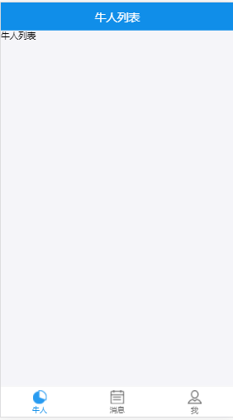 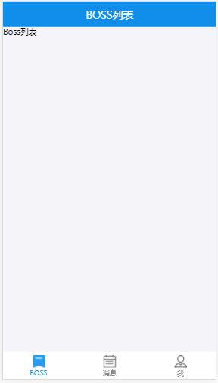

### 13.1. 下载相关依赖包

|  |
| --- |
| **npm install --save browser-cookies** |

### 13.2. 后台路由: server/appRoute.js

|  |
| --- |
| *const _filter = {'pwd': 0, '__v': 0} // 查询时过滤掉*  */* 根据cookie查询用户  */* router.get(**'/info'**, **function** (req, res) {  **const** {userid} = req.**cookies  if** (!userid) {  **return** res.json({**code**: 1})  }  **console**.log(**'/info'**, userid)  UserModel.findOne({**_id**: userid}, _filter, **function** (err, user) {  **console**.log(**'/info'**, user)  **if** (user) {  **return** res.json({**code**: 0, **data**: user})  } **else** {  **return** res.json({**code**: 1})  }  }) }) |

### 13.3. ajax请求模块: api/index.js

|  |
| --- |
| *// 查看用户信息(根据cookie)* **export const** *reqUserInfo* = () => *ajax*(**'/api/info'**) |

### 13.4. redux管理状态

1. redux/action-types.js

|  |
| --- |
| *// 接收用户* **export const** RECEIVE_USER = **'RECEIVE_USER'** *// 重置用户* **export const** RESET_USER = **'RESET_USER'** |

1. redux/actions.js

|  |
| --- |
| **import** {  RECEIVE_USER,  RESET_USER } **from './action-types' import** {  *reqUserInfo* } **from '../api'**  *// 同步接收用户* **const** *receiveUser* = user => ({**type**: RECEIVE_USER, user}) *// 同步重置用户* **const** *resetUser* = () => ({**type**: RESET_USER}) *// 异步获取用户信息* **export const** *getUserInfo* = () => {  **return async** dispatch => {  *// ajax请求获取用户信息* **const** result = **await** *reqUserInfo*()  *// 如果成功* **if** (result.**code** === 0) {  *// 分发同步接收用户的action* dispatch(*receiveUser*(result.**data**))  } **else** {  *// 否则分发同步重置用户的action* dispatch(*resetUser*())  }  } } |

1. redux/reducers.js

|  |
| --- |
| **import** {  RECEIVE_USER,  RESET_USER } **from './action-types'**  **function** *user*(state = initUser, action) {  **switch** (action.**type**) {  **case** RECEIVE_USER: *// 接收用户*  **return** action.**user  case** RESET_USER: *// 重置用户*  **return** {...initUser, **redirectTo**: **'/login'**}  } } |

### 13.5. 面板的子路由

1. containers/boss/boss.jsx

|  |
| --- |
| */* boss的主路由组件  */*  **import** React, {Component} **from 'react'** **export default class** Boss **extends** Component {  render() {  **return** (  <**div**>牛人列表</**div**>  )  } } |

1. containers/genius/genius.jsx

|  |
| --- |
| */* 牛人的主路由组件  */*  **import** React, {Component} **from 'react'** **export default class** Genius **extends** Component {  render() {  **return** (  <**div**>Boss列表</**div**>  )  } } |

1. containers/msg/msg.jsx

|  |
| --- |
| */* 对话消息列表组件  */*  **import** React, {Component} **from 'react'** **export default class** Msg **extends** Component {  render() {  **return** (  <**div**>msg列表</**div**>  )  } } |

1. containers/user/user.jsx

|  |
| --- |
| */* 用户个人中心路由组件  */*  **import** React, {Component} **from 'react'** **export default class** User **extends** Component {  render() {  **return** (  <**div**>个人中心</**div**>  )  } } |

1. components/not-found/not-found.jsx

|  |
| --- |
| */* 提示找不到页面的UI路由组件  */*  **import** React **from "react" import** {Button} **from "antd-mobile"** **class** NotFound **extends** React.Component {  render() {  **return** (  <**div**>  <**div**>  <**h2**>抱歉，找不到该页面!</**h2**>  <**Button  type="primary"  onClick=**{() => **this**.**props**.**history**.push(**"/"**)}  >  回到首页  </**Button**>  </**div**>  </**div**>  )  } }  **export default** NotFound |

### 13.6. 底部导航组件

1. 相关图标图片

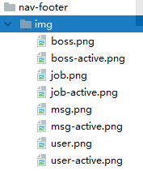

1. 组件: components/nav-footer/nav-footer.jsx

|  |
| --- |
| */* 底部导航的UI组件  */*  **import** React **from 'react' import** PropTypes **from 'prop-types' import** {TabBar} **from 'antd-mobile' import** {**withRouter**} **from 'react-router-dom'  const** Item = TabBar.*Item* **class** NavFooter **extends** React.Component {   **static** *propTypes* = {  **navList**: PropTypes.*array*.isRequired  }  render() {   **const** navList = **this**.**props**.**navList**.filter(v => !v.**hide**)  **const** {pathname} = **this**.**props**.**location  return** (  <**TabBar**>  {navList.map(v => (  <**Item  key=**{v.**path**}  **title=**{v.**text**}  **icon=**{{**uri**: require(**`./img/**${v.**icon**}**.png`**)}}  **selectedIcon=**{{**uri**: require(**`./img/**${v.**icon**}**-active.png`**)}}  **selected=**{pathname === v.**path**}  **onPress=**{() => {  **this**.**props**.**history**.replace(v.**path**)  }}  >  </**Item**>  ))}  </**TabBar**>  )  } }  **export default withRouter**(NavFooter) |

### 13.7. 应用面版路由组件

1. containers/dashboard.jsx

|  |
| --- |
| */* 应用面版路由组件  */* **import** React **from 'react' import** {connect} **from 'react-redux' import** {NavBar} **from 'antd-mobile' import** {**Switch**, **Route**, **Redirect**} **from 'react-router-dom' import** cookies **from 'browser-cookies'  import** NavFooter **from '../../components/nav-footer/nav-footer' import** Boss **from '../boss/boss' import** Genius **from '../genius/genius' import** User **from '../user/user' import** Msg **from '../msg/msg' import** GeniusInfo **from '../genius-info/genius-info' import** BossInfo **from '../boss-info/boss-info' import** NotFound **from '../../components/not-found/not-found' import** {*getUserInfo*} **from '../../redux/actions'** */* 应用面版路由组件  */* **class** Dashboard **extends** React.Component {   **navList** = [  {  **path**: **'/boss'**, *// 路由路径* **component**: Boss,  **title**: **'牛人列表'**,  **icon**: **'boss'**,  **text**: **'牛人'**,  },  {  **path**: **'/genius'**, *// 路由路径* **component**: Genius,  **title**: **'BOSS列表'**,  **icon**: **'job'**,  **text**: **'BOSS'**,  },  {  **path**: **'/msg'**, *// 路由路径* **component**: Msg,  **title**: **'消息列表'**,  **icon**: **'msg'**,  **text**: **'消息'**,  },  {  **path**: **'/me'**, *// 路由路径* **component**: User,  **title**: **'个人中心'**,  **icon**: **'user'**,  **text**: **'我'**,  }  ]   componentDidMount() {  **if** (cookies.*get*(**'userid'**)) {  **const** {user, getUserInfo} = **this**.**props  if** (!user.**_id**) {  getUserInfo()  }  } **else** {  **this**.**props**.**history**.**replace**(**'/login'**)  }  }   render() {  **const** {location, history, user} = **this**.**props** *// 如果用户还不确定, 不显示* **if** (!user.**type**) {  **if** (user.**redirectTo**) {  **return** <**Redirect to=**{user.**redirectTo**}/>  } **else** {  **return null** }  } **else** {  *// 如果用户已确定, 指定需要隐藏的tab* **if** (user.**type** === **'boss'**) { *// boss用户  // 如果指定的是'/', 重定向到'/boss'* **if** (location.**pathname** === **'/'**) {  **return** <**Redirect to='/boss'**/>  }  **this**.**navList**[1].**hide** = **true** } **else** { *// genius用户  // 如果指定的是'/', 重定向到'/genius'* **if** (location.**pathname** === **'/'**) {  **return** <**Redirect to='/genius'**/>  }  **this**.**navList**[0].**hide** = **true** }  }   *// 得到当前路由对应的nav对象* **const** currNav = **this**.**navList**.find(nav => nav.**path** === location.**pathname**)   **return** (  <**div**>  {currNav ? <**NavBar**>{currNav.**title**}</**NavBar**> : **null**}  <**Switch**>  {**this**.**navList**.map(nav => (  <**Route key=**{nav.**path**} **path=**{nav.**path**} **component=**{nav.**component**}/>  ))}  <**Route path='/bossinfo' component=**{BossInfo}/>  <**Route path='/geniusinfo' component=**{GeniusInfo}/>  <**Route component=**{NotFound}/>  </**Switch**>  {currNav ? <**NavFooter navList=**{**this**.**navList**}/> : **null**}  </**div**>  )  } }  **export default** connect(  state => ({**user**: state.**user**}),  {*getUserInfo*} )(Dashboard) |

1. 样式: assets/css/index.css

|  |
| --- |
| .**am-tab-bar**{ /*使导航始终在底部*/  **position**: **fixed**;  **bottom**: 0;  **width**: 100%; } |

## 个人中心功能

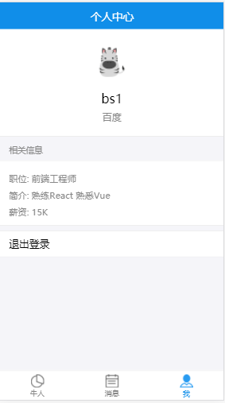 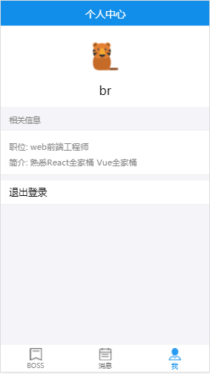

### 14.1. 个人中心组件: containers/user/user.jsx

|  |
| --- |
| */* 用户个人中心路由组件  */* **import** React **from 'react' import** {connect} **from 'react-redux' import** {Result, List, WhiteSpace, Modal} **from 'antd-mobile' import** browserCookies **from 'browser-cookies' import** {*resetUser*} **from '../../redux/actions'  const** Item = List.*Item* **const** Brief = Item.*Brief* **class** User **extends** React.Component {   *logout* = () => {  Modal.*alert*(**'注销'**, **'确认退出登录吗?'**, [  {  **text**: **'取消'**,  onPress: () => **console**.log(**'cancel'**)},  {  **text**: **'确认'**,  onPress: () => {  browserCookies.*erase*(**'userid'**)  **this**.**props**.**resetUser**()  }  }  ])  }   render() {  **const** {name, avatar, type, title, desc, money, company} = **this**.**props   return** (  <**div**>  <**Result  img=**{<**img src=**{require(**`../../assets/imgs/**${avatar}**.png`**)} **style=**{{**width**: 50}} **alt="avatar"**/>}  **title=**{name}  **message=**{type === **'boss'** ? company : **null**}  />   <**List renderHeader=**{() => **'相关信息'**}>  <**Item multipleLine**>  <**Brief**>职位: {title}</**Brief**>  <**Brief**>简介: {desc}</**Brief**>  {money ? <**Brief**>薪资: {money}</**Brief**> : **null**}  </**Item**>  </**List**>  <**WhiteSpace**/>  <**List**>  <**Item onClick=**{**this**.*logout*}>退出登录</**Item**>  </**List**>  </**div**>  )  } }  **export default** connect(  state => state.**user**,  {*resetUser*} )(User) |

### 14.2. 样式: assets/css/index.css

|  |
| --- |
| .**am-tab-bar**{ */*使导航始终在底部*/* **position**: **fixed**;  **bottom**: 0;  **width**: 100%;  **height**: **inherit**; */*高度包裹内容*/* } |

## Boss/牛人列表功能

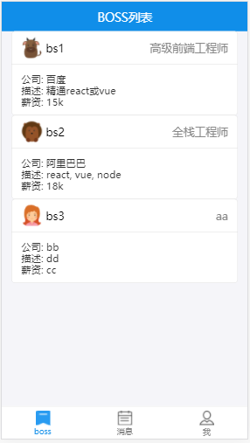 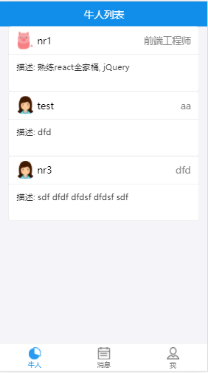

### 15.1. 后台路由: server/appRouter.js

|  |
| --- |
| */* 查看用户列表  */* router.get(**'/list'**,**function**(req, res){  **const** { type } = req.**query** UserModel.find({type},**function**(err,users){  **return** res.json({**code**:0, **data**: users})  }) }) |

### 15.2. ajax请求模块: api/index.js

|  |
| --- |
| *// 请求获取用户列表* **export const** *reqUserList* = (type) => *ajax*(**'/api/list'**, {type}) |

### 15.3. redux管理状态

1. redux/action-types.js

|  |
| --- |
| *// 获取用户列表* **export const** USER_LIST = **'USER_LIST'** |

1. redux/actions.js

|  |
| --- |
| **import** {  USER_LIST } **from './action-types' import** {  *reqUserList* } **from '../api'**  *// 用户列表* **const** *userList* = (users) => ({**type**: USER_LIST, **data**: users}) *// 异步获取用户列表* **export const** *getUserList* = (type) => {  **return async** dispatch => {  **const** result = **await** *reqUserList*(type)  **if** (result.**code** === 0) {  dispatch(*userList*(result.**data**))  }  } } |

1. redux/reducers.js

|  |
| --- |
| **const** initChatUser = {  **userList**: [] }  **function** *chatUser*(state = initChatUser, action) {  **switch** (action.**type**) {  **case** USER_LIST:  **return** {...initChatUser, **userList**: action.**data**}  **default**:  **return** state  } }  **export default** *combineReducers*({  *user*,  *chatUser* }) |

### 15.4. 用户列表组件: components/user-list/user-list.jsx

|  |
| --- |
| */* 用户列表的UI组件  */*  **import** React **from 'react' import** PropTypes **from 'prop-types' import** {Card, WingBlank} **from 'antd-mobile' import** {**withRouter**} **from 'react-router-dom'  const** Header = Card.*Header* **const** Body = Card.Body  **class** UserList **extends** React.Component {   **static** *propTypes* = {  **userList**: PropTypes.*array*.isRequired  }   *handleClick* = user => {  **console**.log(**'click'**, user)  **this**.**props**.**history**.push(**`/chat/**${user.**_id**}**`**, {**name**: user.**name**})  }   render() {  **return** (  <**div**>  <**WingBlank size="lg"**>  {**this**.**props**.**userList**.map(v => (  v.**avatar** ? (  <**Card key=**{v.**_id**} **onClick=**{() => **this**.*handleClick*(v)}>  <**Header  title=**{v.**name**}  **thumb=**{require(**`../../assets/imgs/**${v.**avatar**}**.png`**)}  **extra=**{<**span**>{v.**title**}</**span**>}  />  <**Body**>  {v.**type** === **'boss'** ? (<**div**>公司: {v.**company**}</**div**>) : **null**}  <**div**>描述: {v.**desc**}</**div**>  {v.**type** === **'boss'** ? (<**div**>薪资: {v.**money**}</**div**>) : **null**}  </**Body**>  </**Card**> ) : **null** ))}  </**WingBlank**>  </**div**>  )  } }  **export default withRouter**(UserList) |

### 15.5. BOSS路由组件: containers/boss/boss.jsx

|  |
| --- |
| */* boss的主路由组件  */*  **import** React **from 'react' import** {connect} **from 'react-redux'  import** {*getUserList*} **from '../../redux/actions' import** UserList **from '../../components/user-list/user-list'** **class** Boss **extends** React.Component {   componentDidMount() {  **this**.**props**.**getUserList**(**'genius'**)  }   render() {  **return** <**UserList userList=**{**this**.**props**.**userList**}></**UserList**>  }  }  **export default** connect(  state => state.*chatUser*,  {*getUserList*} )(Boss) |

### 15.6. 牛人路由组件: containers/genius/genius.jsx

|  |
| --- |
| */* 牛人的主路由组件  */*  **import** React **from 'react' import** {connect} **from 'react-redux'  import** {*getUserList*} **from '../../redux/actions' import** UserList **from '../../components/user-list/user-list'** **class** Genius **extends** React.Component {   componentDidMount() {  **this**.**props**.**getUserList**(**'boss'**)  }   render() {  **return** <**UserList userList=**{**this**.**props**.**userList**}></**UserList**>  } }  **export default** connect(  state => state.*chatUser*,  {*getUserList*} )(Genius) |

## 实现实时对话通信功能

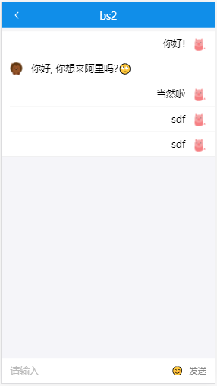 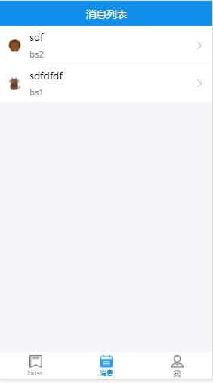

### 16.1. 下载相关依赖包

|  |
| --- |
| **npm install --save-dev socket.io** |

### 16.2 socket.io介绍

1. socket.io是一个能实现多人远程实现通信(聊天)的库
2. 它包装的是H5 WebSocket和轮询, 如果是较新的浏览器内部使用WebSocket, 如果浏览器不支持, 那内部就会使用轮询实现实时通信
3. 学习资料

<https://socket.io/get-started/chat/>

<http://blog.csdn.net/neuq_zxy/article/details/77531126>

### 16.3. 后台实现

1. 添加新的数据库集合模型: server/models.js

|  |
| --- |
| **const** models = {  **chat**: {  **'chat_id'**: {**'type'**: String, **'require'**: **true**},  **'from'**: {**'type'**: String, **'require'**: **true**},  **'to'**: {**'type'**: String, **'require'**: **true**},  **'read'**: {**'type'**:Boolean, **'require'**: **false**},  **'content'**: {**'type'**: String, **'require'**: **true**, **'default'**: **''**},  **'create_time'**: {**'type'**: Number, **'default'**: **new** Date().getTime()}  } } |

1. 新增路由: server/appRouter.js

|  |
| --- |
| **const** ChatModel = models.getModel(**'chat'**)  */* 获取所有交流信息列表  */* router.get(**'/getmsgs'**, **function**(req, res) {  **const** userid = req.**cookies**.**userid** UserModel.find({}, **function** (err, userdocs) {  **const** users = {}  userdocs.forEach(user => {  users[user.**_id**] = {**name**: user.**name**, **avatar**: user.**avatar**}  })  ChatModel.find(  {**'$or'**:[{**from**:userid}, {**to**: userid}]},  **function**(err, msgDocs) {  **return** res.json({**code**: 0, **msgs**: msgDocs, users})  }  )  }) })  */* 修改指定消息为已读  */* router.post(**'/readmsg'**, **function** (req, res) {  **const** to = req.**cookies**.**userid  const** from = req.**body**.**from** ChatModel.update({from, to}, {**read**: **true**}, {**multi**: **true**}, **function** (err, doc) {  **console**.log(doc)  **console**.log(**'/readmsg'**, to, from, doc.**nModified**)  **if**(!err) {  **return** res.send({**code**: 0, **data**: doc.**nModified**})  } **else** {  **return** res.send({**code**: 0, **msg**: **'修改已读状态失败'**})  }  }) }) |

1. 使用上socket.io实现实时通信: server/server.js

|  |
| --- |
| **const** ChatModel = require(**'./models'**).getModel(**'chat'**) **const** server = require(**'http'**).Server(app) **const** io = require(**'socket.io'**)(server)  io.on(**'connection'**, **function**(socket) {  **console**.log(**'soketio connected'**)  *// 绑定sendMsg监听, 接收客户端发送的消息* socket.on(**'sendMsg'**, **function**(data) {  **console**.log(**'sendmsg'**, data)   **const** {from, to, msg} = data  **const** chat_id = [from, to].sort().join(**'_'**)  ChatModel.create({chat_id, from, to, **content**: msg}, **function**(err, doc) {  **if**(!err) {  **console**.log(**'recvMsg'**, doc.**_doc**)  *// 向客户端发送接收并保存了消息的消息* io.emit(**'recvMsg'**, Object.assign({},doc.**_doc**))  }  })  }) })  server.listen(8888, **function**(){  **console**.log(**'app listening at port 8888'**); }) |

### 16.4. ajax请求模块: api/index.js

|  |
| --- |
| *// 获取所有消息的列表* **export const** *reqMsgs* = () => *ajax*(**'/api/getmsgs'**) *// 发送读取了特定消息的请求* **export const** *reqReadMsg* = (from) => *ajax*(**'/api/readmsg'**, {from}, **'POST'**) |

### 16.5. redux管理状态

1. redux/action-types.js

|  |
| --- |
| *// 获取聊天消息列表* **export const** MSG_LIST = **'MSG_LIST'** *// 接收到消息* **export const** MSG_RECV = **'MSG_RECV'** *// 标识消息已读* **export const** MSG_READ = **'MSG_READ'** |

1. redux/actions.js

|  |
| --- |
| **import** io **from 'socket.io-client' import** {  *reqMsgs*,  *reqReadMsg* } **from '../api' import** {  MSG_LIST,  MSG_RECV,  MSG_READ } **from './action-types'  const** socket = io(**'ws://localhost:8888'**)  **const** *msgList* = (msgs, users, userId) => ({**type**: MSG_LIST, **data**: {msgs, users, userId}}) **const** *msgRecv* = (msg, userId) => ({**type**: MSG_RECV, **data**: {msg, userId}}) **const** *msgRead* = (from, to, num) => ({**type**: MSG_READ, **data**: {from, to, num}}) *// 异步获取消息列表* **export const** *getMsgList* = () => {  **return async** (dispatch, getState) => {  **const** result = **await** *reqMsgs*()  **if**(result.**code**===0) {  **const** userId = getState().**user**.**_id** dispatch(*msgList*(result.**msgs**, result.**users**, userId))  }  } } *// 发送消息* **export function** *sendMsg*({from, to, msg}) {  **return** dispatch => {  socket.emit(**'sendMsg'**, {from, to, msg})  } } *// 接收消息* **export function** *recvMsg*() {  **console**.log(**'recvMsg()'**)  **return** (dispatch, getState) => {  **if**(!socket.**recvMsg**) {  socket.on(**'recvMsg'**, **function** (msg) {  **const** userId = getState().**user**.**_id** dispatch(*msgRecv*(msg, userId))  })  socket.**recvMsg** = **true** }  } } *// 查看了与特定用户的消息* **export const** *readMsg* = (from) => {  **return async** (dispatch, getState) => {  **const** result = **await** *reqReadMsg*(from)  **if**(result.**code**===0) {  **const** to = getState().**user**.**_id  if**(result.**data**>0) {  dispatch(*msgRead*(from, to, result.**data**))  }  }  } } |

1. redux/reducers.js

|  |
| --- |
| **import** {  MSG_LIST,  MSG_RECV,  MSG_READ } **from './action-types'**  **const** initChat = {  **chatMsgs**: [],  **users**: {},  **unread**: 0 }  **export function** *chat*(state=initChat, action) {  **switch**(action.**type**) {  **case** MSG_LIST:  **return** {...state,  **chatMsgs**: action.**data**.**msgs**,  **users**: action.**data**.**users**,  unread: action.**data**.**msgs**.filter(v=>!v.**read** && v.**to**===action.**data**.**userId**).**length**}  **case** MSG_RECV:  **const** {msg, userId} = action.**data  const** addCount = userId===msg.**to** ? 1 : 0  **return** {...state, **chatMsgs**: [...state.**chatMsgs**, action.**data**.**msg**], **unread**: state.**unread**+addCount}  **case** MSG_READ:  **return** {...state, chatMsgs:state.**chatMsgs**.map(msg => ({...msg, **read**:**true**})), **unread**: state.**unread**-action.**data**.**num**}  **default**:  **return** state  } }  **export default** *combineReducers*({  *user*,  *chatUser*,  *chat* }) |

### 16.6. 聊天组件: containers/chat/chat.jsx

|  |
| --- |
| */* 对话聊天的路由组件  */*  **import** React **from 'react' import** {connect} **from 'react-redux' import** {List,InputItem, NavBar, Icon, Grid} **from 'antd-mobile'  import** {*sendMsg*, *readMsg*} **from '../../redux/actions'  const** Item = List.*Item* **class** Chat **extends** React.Component {   **state** = {  **text**: **''**,  **isShow**: **false** }   componentWillMount () {  **this**.**emojis** = [**''**, **''**, **''**, **''**, **''**, **''**, **'❤'**, **''**, **''**, **''**, **''**, **''**, **''**, **''**,  **''**, **''**, **''**, **''**, **''**, **''**, **'❤'**, **''**, **''**, **''**, **''**, **''**, **''**, **''**,  **''**, **''**, **''**, **''**, **''**, **''**, **'❤'**, **''**, **''**, **''**, **''**, **''**, **''**, **''**]  **this**.**emojis** = **this**.**emojis**.map(value => ({**text**: value}))  **console**.log(**this**.**emojis**)  }   componentDidMount() {  **const** from = **this**.**props**.**match**.**params**.**id  const** unread = **this**.**props**.**location**.**state  if**(unread) {  **this**.**props**.**readMsg**(from)  }  **window**.scrollTo(0, **document**.**body**.**scrollHeight**);  }   componentWillReceiveProps () {  **console**.log(**'componentWillReceiveProps()'**)  **this**.**propsUpdate** = **true** }   componentDidUpdate() {  **if**(**this**.**propsUpdate**) {  **console**.log(**'ChatList scrollTo'**)  **window**.scrollTo(0, **document**.**body**.**scrollHeight**);  **this**.**propsUpdate** = **false** }  }   *handleSubmit* = () => {  **const** from = **this**.**props**.**user**.**_id  const** to = **this**.**props**.**match**.**params**.**id  const** msg = **this**.**state**.**text  this**.**props**.**sendMsg**({from, to, msg})  **this**.setState({**text**: **''**})  }   *toggleShow* = () => {  **const** isShow = !**this**.**state**.**isShow  this**.setState({isShow})  **if**(isShow) {  *// 异步手动派发resize事件* setTimeout(() => {  **window**.dispatchEvent(**new** Event(**'resize'**))  }, 0)  }  }   render() {  **const** userid = **this**.**props**.**match**.**params**.**id  const** users = **this**.**props**.*chat*.**users  if** (!users[userid]) {  **return null** }  **const** chatId = [**this**.**props**.**user**.**_id**, userid].sort().join(**'_'**)  **const** chatMsgs = **this**.**props**.*chat*.**chatMsgs**.filter(v => {  **return** v.**chat_id** === chatId  })  **return** (  <**div id='chat-page'**>  <**div className='stick-top'**>  <**NavBar  mode='dark'  icon=**{<**Icon type='left'**/>}  **onLeftClick=**{() => {  **this**.**props**.**history**.**goBack**()  }}  >  {users[userid].**name**}  </**NavBar**>  </**div**>  <**List style=**{{**marginTop**: 50, **marginBottom**: 50}}>  {chatMsgs.map(msg => {  **const** avatar = require(**`../../assets/imgs/**${users[msg.**from**].**avatar**}**.png`**)  **if** (msg.**from** === userid) {  **return** (  <**Item  key=**{msg.**_id**}  **thumb=**{avatar}  >{msg.**content**}</**Item**>  )  } **else** {  **return** (  <**Item  key=**{msg.**_id**}  **extra=**{<**img src=**{avatar}/>}  **className='chat-me'** >{msg.**content**}</**Item**>  )  }  })}  </**List**>   <**div className="am-tab-bar"**>  <**InputItem  placeholder="请输入"  value=**{**this**.**state**.**text**}  **onChange=**{v => {  **this**.setState({**text**: v})  }}  **onFocus=**{() => {**this**.setState({**isShow**: **false**})}}  **extra=**{  <**div**>  <**span  onClick=**{**this**.*toggleShow*}  **style=**{{**marginRight**: 10}}>笑脸</**span**>  <**span onClick=**{**this**.*handleSubmit*}>发送</**span**>  </**div**>  }  ></**InputItem**>   {  **this**.**state**.**isShow** ? (  <**Grid  data=**{**this**.**emojis**}  **columnNum=**{8}  **carouselMaxRow=**{4}  **isCarousel=**{**true**}  **onClick=**{(item) => {  **this**.setState({**text**: **this**.**state**.**text** + item.**text**})  }}  />  ) : **null** }   </**div**>  </**div**>  )  } }  **export default** connect(  state => state,  {*sendMsg*, *readMsg*} )(Chat) |

### 16.7. 消息列表组件: containers/msg/msg.jsx

|  |
| --- |
| */* 对话消息列表组件  */*  **import** React, {Component} **from 'react' import** {connect} **from 'react-redux' import** {List, Badge} **from 'antd-mobile'  const** Item = List.*Item* **const** Brief = Item.*Brief* **class** Msg **extends** Component {   render () {  **const** userId = **this**.**props**.**user**.**_id  const** chatUsers = **this**.**props**.*chat*.**users   const** msgGroup = {}  **this**.**props**.*chat*.**chatMsgs**.forEach(msg => {  msgGroup[msg.**chat_id**] = msgGroup[msg.**chat_id**] || []  msgGroup[msg.**chat_id**].push(msg)  })  **const** chatList = Object.values(msgGroup).sort((a, b) => {  **const** aLast = a[a.**length**-1].**create_time  const** bLast = b[b.**length**-1].**create_time  return** bLast-aLast  })  **console**.log(chatList)  **return** (  <**div**>  <**List**>  {  chatList.map(chatItem => {  **const** lastMsg = chatItem[chatItem.**length**-1]  **const** targetId = lastMsg.**from**===userId ? lastMsg.**to** : lastMsg.**from  const** targetUer = chatUsers[targetId]  **const** unread = chatItem.reduce(  (total, msg) => total + (!msg.**read**&&msg.**to**===userId ? 1: 0), 0)   **return** (  <**Item  key=**{lastMsg.**_id**}  **extra=**{<**Badge text=**{unread}/>}  **thumb=**{require(**`../../assets/imgs/**${targetUer.**avatar**}**.png`**)}  **arrow='horizontal'  onClick=**{() => {  **this**.**props**.**history**.push(**`/chat/**${targetId}**`**, unread)  }}  >  {lastMsg.**content**}  <**Brief**>{targetUer.**name**}</**Brief**>  </**Item**>  )  })  }  </**List**>  </**div**>  )  } }  **export default** connect(  state => state )(Msg) |

### 16.8. 应用面板组件: containers/dashboard/dashboard.jsx

|  |
| --- |
| */* 应用面版的路由组件  */*  **import** React **from 'react' import** {connect} **from 'react-redux' import** {NavBar} **from 'antd-mobile' import** {**Switch**, **Route**} **from 'react-router-dom' import** cookies **from 'browser-cookies'  import** NavFooter **from '../../components/nav-footer/nav-footer' import** Boss **from '../boss/boss' import** Genius **from '../genius/genius' import** User **from '../user/user' import** Msg **from '../msg/msg' import** GeniusInfo **from '../genius-info/genius-info' import** BossInfo **from '../boss-info/boss-info' import** NotFound **from '../../components/not-found/not-found' import** Chat **from '../chat/chat' import** {*getUserInfo*, *getMsgList*, *recvMsg*} **from '../../redux/actions'** **class** Dashboard **extends** React.Component {   **navList** = [  {  **path**: **'/boss'**,  **text**: **'牛人'**,  **icon**: **'boss'**,  **title**: **'牛人列表'**,  **component**: Boss,  **hide**: **false** },  {  **path**: **'/genius'**,  **text**: **'boss'**,  **icon**: **'job'**,  **title**: **'BOSS列表'**,  **component**: Genius,  **hide**: **false** },  {  **path**: **'/msg'**,  **text**: **'消息'**,  **icon**: **'msg'**,  **title**: **'消息列表'**,  **component**: Msg  },  {  **path**: **'/me'**,  **text**: **'我'**,  **icon**: **'user'**,  **title**: **'个人中心'**,  **component**: User  }  ]   componentDidMount() {  **const** {history, user, getUserInfo} = **this**.**props** *// 判断是否登陆过* **if** (cookies.*get*(**'userid'**)) {  *// 判断是否已经拉取用户信息* **if** (!user.**name**) {  getUserInfo()  }  } **else** {  history.replace(**"/login"**);  }   *// 获取消息列表* **this**.**props**.**getMsgList**()  *// 绑定接收消息的监听* **this**.**props**.**recvMsg**()  }   componentWillReceiveProps(nextProps) {  **if** (!nextProps.**user**.**name**) {  **this**.**props**.**history**.replace(**'/login'**)  }  }   render() {  **const** {location, user, history, chat} = **this**.**props**;  **if** (!user.**type**) {  **return null** } **else** {  **if** (location.**pathname** === **'/'**) {  **if** (user.**type** === **'boss'**) {  history.replace(**'/boss'**)  } **else** {  history.replace(**'/genius'**)  }   **return null** }  }  **if** (user.**type** === **'genius'**) {  **this**.**navList**[0].**hide** = **true** } **else if** (user.**type** === **'boss'**) {  **this**.**navList**[1].**hide** = **true** }   **const** currentNav = **this**.**navList**.find(nav => nav.**path** === location.**pathname**)  **return** (  <**div**>  {currentNav ? <**NavBar mode='dard'**>{currentNav.**title**}</**NavBar**> : **null**}  <**div**>  <**Switch**>  {**this**.**navList**.map(v => (  <**Route key=**{v.**path**} **path=**{v.**path**} **component=**{v.**component**}></**Route**>  ))}  <**Route path='/bossinfo' component=**{BossInfo}></**Route**>  <**Route path='/geniusinfo' component=**{GeniusInfo}></**Route**>  <**Route path='/chat/:id' component=**{Chat}></**Route**>  <**Route component=**{NotFound}/>  </**Switch**>  </**div**>  {currentNav ? <**NavFooter navList=**{**this**.**navList**} **unread=**{chat.**unread**}/> : **null**}  </**div**>  )  } }  **export default** connect(  state => state,  {*getUserInfo*, *getMsgList*, *recvMsg*} )(Dashboard) |

### 16.9. 显示未读消息数量: components/nav-footer/nav-footer.jsx

|  |
| --- |
| */* 底部导航的UI组件  */*  **import** React **from 'react' import** PropTypes **from 'prop-types' import** {TabBar} **from 'antd-mobile' import** {**withRouter**} **from 'react-router-dom'  const** Item = TabBar.*Item* **class** NavFooter **extends** React.Component {   **static** *propTypes* = {  **navList**: PropTypes.*array*.isRequired,  **unread**: PropTypes.*number*.isRequired  }   render() {   **const** navList = **this**.**props**.**navList**.filter(v => !v.**hide**)  **const** {pathname} = **this**.**props**.**location  return** (  <**TabBar**>  {navList.map(v => (  <**Item  badge=**{v.**path** === **'/msg'** ? **this**.**props**.**unread** : 0}  **key=**{v.**path**}  **title=**{v.**text**}  **icon=**{{**uri**: require(**`./img/**${v.**icon**}**.png`**)}}  **selectedIcon=**{{**uri**: require(**`./img/**${v.**icon**}**-active.png`**)}}  **selected=**{pathname === v.**path**}  **onPress=**{() => {  **this**.**props**.**history**.replace(v.**path**)  }}  >  </**Item**>  ))}  </**TabBar**>  )  } }  **export default withRouter**(NavFooter) |

### 16.11. 样式: assets/css/index.css

|  |
| --- |
| **#chat-page** .**stick-top** { */*固定在顶部*/* **z-index**: 10;  **position**: **fixed**;  **top**: 0;  **width**: 100%; }  */*消息文本居右*/* **#chat-page** .**chat-me** .**am-list-extra** {  **flex-basis**: **auto**; } **#chat-page** .**chat-me** .**am-list-content** {  **padding-right**: 15**px**;  **text-align**: **right**; } |

### 16.12. 添加聊天的页面的动画效果

1. 下载依赖包

|  |
| --- |
| **npm install --save rc-queue-anim** |

1. 在聊天组件使用: containers/chat/chat.jsx

|  |
| --- |
| **import** QueueAnim **from 'rc-queue-anim'**  <**QueueAnim type='scale' delay=**{100}>  {chatMsgs.map(msg => {  **const** avatar = require(**`../../assets/imgs/**${users[msg.**from**].**avatar**}**.png`**)  **if** (msg.**from** === userid) {  **return** (  <**Item  key=**{msg.**_id**}  **thumb=**{avatar}  >{msg.**content**}</**Item**>  )  } **else** {  **return** (  <**Item  key=**{msg.**_id**}  **extra=**{<**img src=**{avatar}/>}  **className='chat-me'** >{msg.**content**}</**Item**>  )  }  })} </**QueueAnim**> |